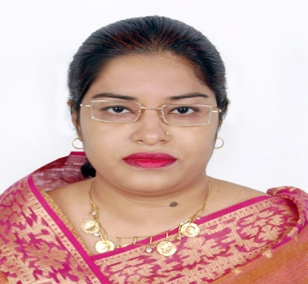
Curriculum vitae
Name: Aklima Akter
Address: 64/3/A, R.K. Mission Road, Gopibugh
Dhaka-1203
Mobile: +8801731177449
E-mail: shimu.adib@gmail.com

Objective: To be secure a responsible career opportunity to fully utilize my training and skills, while making a significant contribution to the success at an institution where I can teach with care and support my students to do well in their studies.
Profile: An outgoing and articulate graduate with work experience in teaching.
Personal Details:
Fathers name: Rustam Ali (late)
Mothers name: Nurjahan Begum
Permanent address: 64/3/A, R.K. Mission Road, Gopibugh, Dhaka 1203.
Date of Birth: 21 June, 1977
Nationality: Bangladeshi by birth
Marital status: Married
Religion: Islam
Education:
SSC. | 1st Division | 1992 | Shahid Nobi High School | Dhaka Board
HSC | 1st Division | 1994 | Central Women’s College | Dhaka Board
BA (Hons) in English | 3rd class | 2000 | Jagannath College and university | National university
MA (English Literature) | CGPA- 3.21(4) | 2006 | Stamford University, Dhanmondi, Dhaka-2006.

Professional Training & skills:
- B.ED. Darul Ihsan University, Dhaka – 2011 CGPA- 3.69 (4).
- NTRCA Certificate- Teachers’ Registration Examination
2008, Reg. no.- 80018444// 2008, Roll number- 10111927.
- Teachers Curriculumn Guide’’ at secondary level- May, 2019.
- Performance Based Management (PBM)- May, 2019.
- Teacher Development programme- British Council- 2009.
- 2nd TESOL BD National Teacher Training Workshops-2023.- TESOL.BD
Skills:
- Certificate Course in computer Applications- (3 months)- ‘A’
- Language: Bangla, English
Work Experience:

# I had worked for a pre-school for three years as an English teacher.
# I had worked for six months for a secondary school at Jatrabari for five months.
# I have been working for Sher-e- Bangla Balika Mohabiddaloy from 22-07-2013 to till today.
Interests:
# Reading books, teaching, watching tv and entertaining friends.

Signature

